Project Design Phase-II
Technology Stack (Architecture & Stack)
Date | 29 September 2026
Team ID | SWTID-2026-3914
Project Name | Implement Client Script & UI Policy (Incident)
Maximum Marks | 4 Marks
Technical Architecture:
The Deliverable shall include the architectural diagram as below and the information as per the table1 & table 2
Example: Order processing during pandemics for offline mode
Reference: https://developer.ibm.com/patterns/ai-powered-backend-system-for-order-processingduring-pandemics/
Guidelines:
Include all the processes (As an application logic /
Technology Block)
Provide infrastructural demarcation (Local / Cloud)
Indicate external interfaces (third party API’s etc.)
Indicate Data Storage components / services Indicate interface to machine learning models (if applicable)
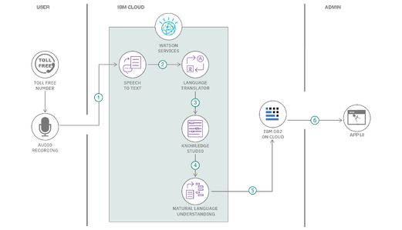
Table-1 : Components & Technologies:

S.No | Component | Description | Technology
1. | User Interface | How user interacts with application e.g.  Web UI, Mobile App, Chatbot etc. | HTML, CSS, JavaScript / Angular Js / React Js etc.
1. | Application Logic-1 | Logic for a process in the application | Java / Python
1. | Application Logic-2 | Logic for a process in the application | IBM Watson STT service
1. | Application Logic-3 | Logic for a process in the application | IBM Watson Assistant
1. | Database | Data Type, Configurations etc. | MySQL, NoSQL, etc.
1. | Cloud Database | Database Service on Cloud | IBM DB2, IBM Cloudant etc.
1. | File Storage | File storage requirements | IBM Block Storage or Other  Storage Service or Local  Filesystem
1. | External API-1 | Purpose of External API used in the application | IBM Weather API, etc.
1. | External API-2 | Purpose of External API used in the application | Aadhar API, etc.
1. | Machine Learning Model | Purpose of Machine Learning  Model | Object Recognition Model, etc.
1. | Infrastructure (Server /  Cloud) | Application Deployment on Local System / Cloud  Local Server Configuration:  Cloud Server Configuration : | Local, Cloud Foundry, Kubernetes, etc.
Table-2: Application Characteristics:
S.No | Characteristics | Description | Technology
1. | Open-Source Frameworks | List the open-source frameworks used | Technology of Opensource framework
1. | Security Implementations | List all the security / access controls implemented, use of firewalls etc. | e.g. SHA-256, Encryptions, IAM Controls, OWASP etc.
1. | Scalable Architecture | Justify the scalability of architecture (3 – tier, Microservices) | Technology used
1. | Availability | Justify the availability of application  (e.g. use of load balancers, distributed servers etc.) | Technology used
1. | Performance | Design consideration for the performance of the application (number of requests per sec, use of Cache, use of CDN’s) etc. | Technology used
References:
https://c4model.com/ https://developer.ibm.com/patterns/online-order-processing-system-during-pandemic/ https://www.ibm.com/cloud/architecture https://aws.amazon.com/architecture
https://medium.com/the-internal-startup/how-to-draw-useful-technical-architecture-diagrams2d20c9fda90d

